In 1828, issues in international trade induced the federal government of the United States of America to pass a trade tariff to protect American industry, the last in a series of measures enacted in response to world-wide economic turmoil which had boiled over during and after the War of 1812 and the Napoleonic Wars. Low-priced imports were cutting severely into the gross national product of American manufacturing. Congress determined that a tax on imported goods was in order, thus passing the Tariff of 1828 on May 13. Its intent was to protect American industry, which happened to be located mostly in the Northern states.

During Congressional debate, Southerners soon renamed this measure the “Tariff of Abominations” because of the hardship they believed it would inflict upon their economy. South Carolina’s John C. Calhoun (Vice President from 1825 until 1832, under both John Quincy Adams and Andrew Jackson), leading many other Southerners, argued that the whole series of tariffs, including the Tariff of 1828, were unconstitutional “because they favored one sector of the economy over another.”

Calhoun’s argument proved correct. The tariff was harmful to the Southern states, where agriculture dominated and little manufacturing existed. Not only did Southern states have to pay higher prices on manufactured goods that they did not produce themselves, but it also affected their trade with Great Britain, limiting the importation of British goods and elevating prices on cotton exports, thereby reducing British demand for cotton.
Nullification cartoon - 1832
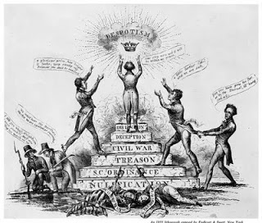
Ultimately this led to the Nullification Crisis. Calhoun argued that if the federal government does not allow a state to nullify a law deemed unconstitutional (giving the state the right to refuse application of that law within the state), then that state has the right to secede from the Union.

Congress made the situation worse by passing the Force Bill in early 1833, giving the president authority to use the military to force the states to obey all federal laws. Under this new law, President Jackson increased tensions further by sending naval warships to Charlestown, S.C. Finally, before it came to bloodshed, Senator Henry Clay offered the Compromise Tariff of 1833, passed on March 2, which altered the Tariff of 1828 to provide the more equitable balance which Calhoun (now Senator), South Carolina, and the other Southern states sought. (5) Secession of South Carolina was averted. The stage had been set, however; the idea and power of the secession argument were not dead, but only slept for the next thirty years.

