Name:
Period:

The Mexican American War of 1846
Essential Question: Was the United States justified in going to war with Mexico?

Document | Points
Understanding the Question | / 10
Hook Exercise | / 15
Background Essay | / 15
Document A – John O’Sullivan Writing | / 15
Document B – War Message of President Polk | / 15
Document C – A Mexican Viewpoint | / 15
Document D – Speech of Senator Sumner | / 15
TOTAL PROJECT POINTS | / 100

Understanding the Question

- What is the essential question asked by this assignment?

- What is the meaning of “justified”?

- Rewrite the question in your own words.

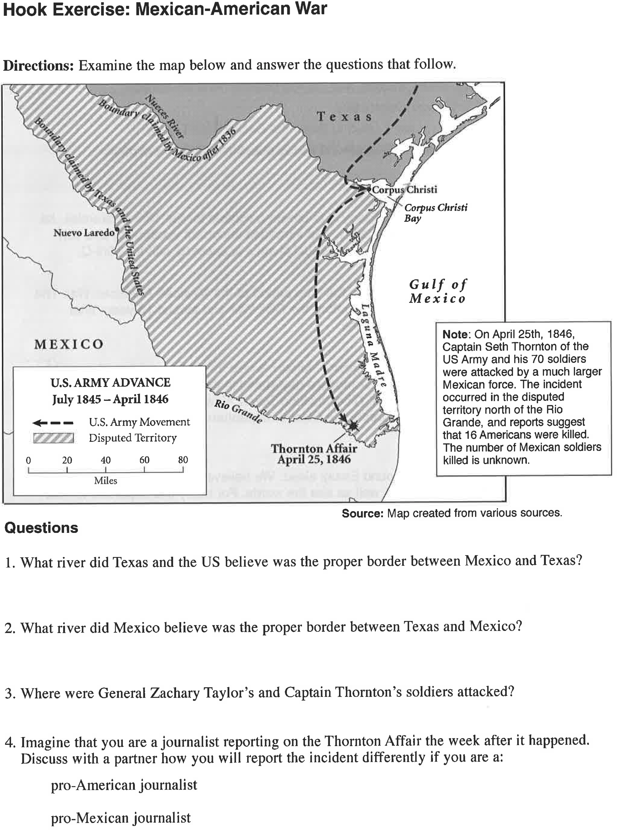

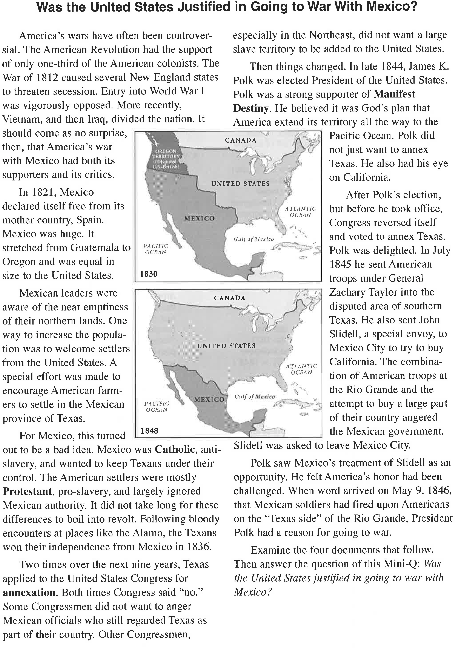
Background Essay

Background Essay Questions

- In what year did Mexico win its independence from Spain?

- In what year did Texas win its independence from Mexico?

3 Define or explain each of these items.

- Catholic

- Protestant

- annexation

- Manifest Destiny

4. Why would Mexican officials have been upset by the annexation of Texas by the United States?

