Name: ________________________________________ Date: ________________________ Period: ________

The Embargo Act of 1807 and Non-Intercourse Act of 1809
Directions: Read the passage below and analyze the political cartoon. Then answer the questions that follow.

The Embargo Act of 1807 was a general embargo (ban) enacted by the United States against Great Britain and France during the Napoleonic Wars. The embargo was imposed in response to violations of U.S. neutrality in which American merchantmen and their cargo were seized as contraband of war by the European navies. The British Royal Navy, in particular, resorted to impressment, forcing thousands of American seamen into service on their warships. Great Britain and France, engaged in a struggle for control of Europe, rationalized the plunder of U.S. shipping as incidental to war and necessary for their survival. President Thomas Jefferson acted with restraint as these rivalries mounted, weighing public support for retaliation. He recommended that Congress respond with commercial warfare, rather than with military mobilization. The Embargo Act was signed into law on December 22, 1807. The anticipated effect of this drastic measure – economic hardship for the warring nations, was expected to punish Great Britain and France, and force them to respect U.S. neutrality, and stop the policy of impressment. The embargo turned out to be impractical, and was a failure both diplomatically and economically. As implemented, the Embargo Act inflicted devastating burdens on the U.S. economy and the American people.
In the last days of President Thomas Jefferson's presidency, the United States Congress replaced the Embargo Act of 1807 with the almost unenforceable Non-Intercourse Act of 1809. This Act lifted all embargoes on American shipping except for those bound for British or French ports. The intent was to damage the economies of Great Britain and France. Like its predecessor, the Embargo Act, it was mostly ineffective, and contributed to the War of 1812. In addition, it seriously damaged the economy of the United States due to a lack of markets for its goods. In summary, both the Embargo Act and Non-Intercourse Act, were diplomatic responses designed to protect American interests and avoid war. However, they ultimately failed and helped cause war. These Acts were bitterly opposed by many Americans, especially New England shipping interests, which suffered greatly from them.
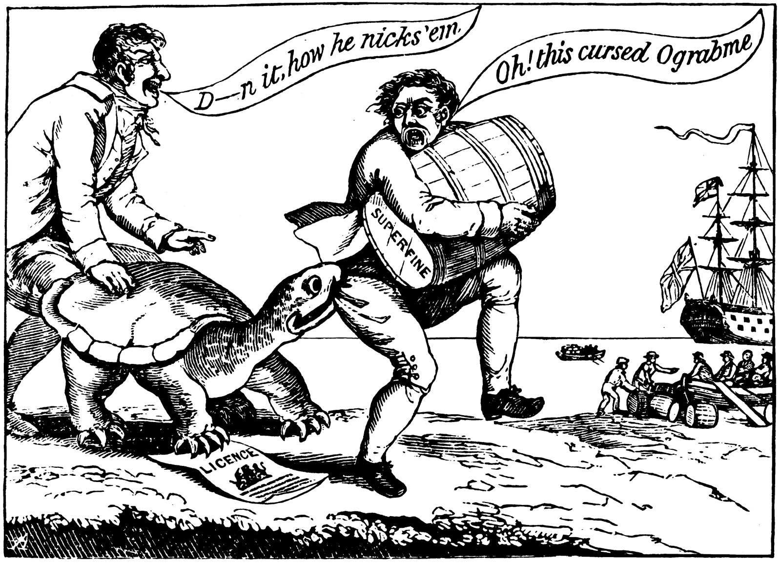

- What was the Embargo Act of 1807?

___________________________________________________________________________________________
___________________________________________________________________________________________

- What is impressment?

___________________________________________________________________________________________
___________________________________________________________________________________________

- What was the Non-Intercourse Act of 1809?

___________________________________________________________________________________________
___________________________________________________________________________________________

- Were these Acts successes or failures? Why?

___________________________________________________________________________________________
___________________________________________________________________________________________

- Why does the cartoonist show the turtle biting the smuggler in this political cartoon?

___________________________________________________________________________________________
___________________________________________________________________________________________

- What is the smuggler saying? *Hint what does Ograbme spell backwards?

___________________________________________________________________________________________
___________________________________________________________________________________________

- What does the cartoonist along with many other Americans think about the Embargo Act?

___________________________________________________________________________________________
___________________________________________________________________________________________

